7. FLYWHEEL
COEFFICIENT OF FLUCTUATION OF ENERGY:  $$C_{E}=\frac{Max fluctuation of energy}{Energy Supplied in a cycle}$$ | $$\begin{matrix}Energy Supplied \\ in a cycle\end{matrix}=\int_{0}^{\begin{matrix}Cycle \\ Time\end{matrix}}{T_{Supply}dθ}=T_{mean} \begin{matrix}Cycle \\ Time\end{matrix}$$  Where, $T_{Supply}=f(θ)$
From conservation of energy, $Net Energy Supplied per cycle=Net Energy Required per cycle$
$$C_{E}=\frac{Max fluctuation of energy}{Energy Supplied in a cycle}=\frac{{\left(∆KE\right)}_{max}}{Net Energy Supplied per cycle}=\frac{{\left(∆KE\right)}_{max}}{Net Energy Required per cycle}$$
CENTRIFUGAL STRESS IN FLYWHEEL (RIM/ RING TYPE):
Centrifugal Force in element,  $$dF_{C}=ρ\left(dV\right)rω^{2}=ρ\left(rdθ bt\right)rω^{2}$$  At equilibrium,$\sum{F_{y}}=0$  $$\int_{0}^{π}{dF_{C}\sin{θ}}=2σbt⇒σ=ρω^{2}r^{2}=ρv^{2}$$ | $b=$ Radial thickness of the flywheel,  $t=$ Axial Width of the flywheel,  $v=$ Linear Velocity of the flywheel at $r$,  $ω=$ Angular Velocity of the flywheel,  $ρ=$ Density of the rim material,  $σ=$ Centrifugal Stress,
OBSERVATIONS:
- FUNCTION-TIME PERIOD: At the X-Time period the mean of the function becomes zero.
$$\sin{nθ}-{2π}/n$$ | $$\cos{nθ}-{2π}/n$$ | $$\tan{nθ}-π/n$$
- $T_{Flywheel}=I_{Flywheel}α_{Flywheel}=T_{Fluctuation}=T_{Supply}-T_{Load}=T_{Supply}-T_{mean}=f(θ)$
For Max fluctuation of energy or crank Position/ Angle at which flywheel will be subjected to maximum acceleration or retardation,
$${dT_{Flywheel}}/{dθ}=0⇒θ_{max or min} can be obtain$$
$$θ_{max or min}=+ve CCW$$ | $$θ_{max or min}=-ve CW$$ | $$θ^{'}=θ_{max or min}±Time period of f({dT_{Flywheel}}/{dθ}=0)$$
Amplitude of $T_{Flywheel}$,$T_{Flywheel}=\sqrt{Sqare of coefficient of f(θ)}$
If ${\left.T_{Flywheel}\right|}_{θ^{'}}>0$, Flywheel is accelerating. | If ${\left.T_{Flywheel}\right|}_{θ^{'}}<0$, Flywheel is retarding.
- Isolated Location: At isolated locations, $T_{Supply}=T_{Load}$.
From the figure, Energy of the flywheels,
$$E_{B}=E_{A}+A_{1}=E_{max}$$ | $$E_{C}=E_{B}-A_{1}=E_{A}=E_{min}$$ | $$E_{D}=E_{A}+A_{1}=E_{max}$$ | $$E_{E}=E_{A}=E_{min}$$
$${\left(∆KE\right)}_{max}=E_{max}-E_{min}=A_{1}=\int_{θ_{A}}^{θ_{B}}{\left(T_{Supply}-T_{Load}\right)}dθ=Iω_{mean}^{2}C_{S}$$
PUNCHING MACHINE:
Angle turned by the crank in 1 cycle $=2π$ (Forward + Return Stroke) |  | 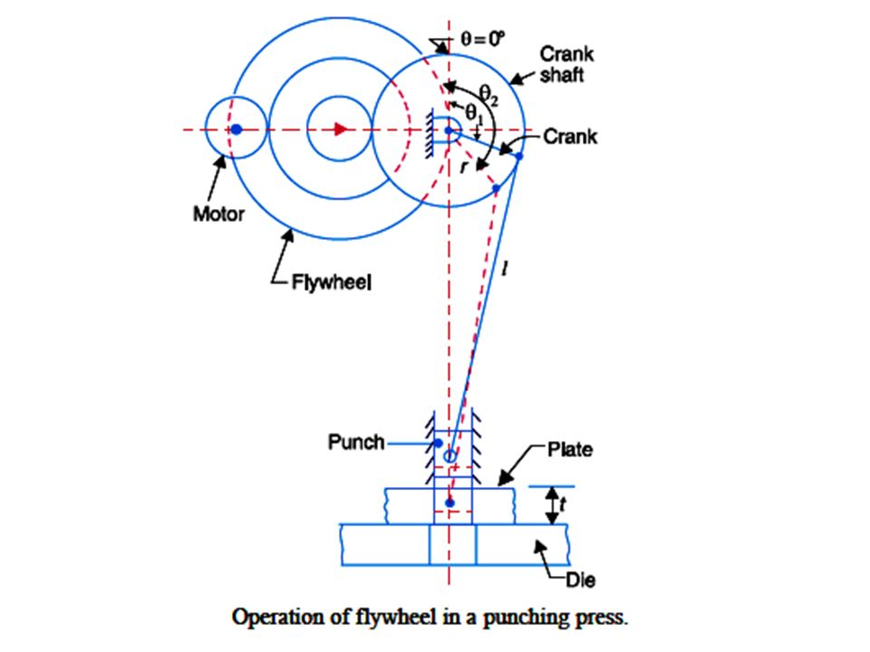
$t=$ Thickness of the plate, | $0≤θ≤θ_{1}:$ Tool moves in air,
$θ_{1}≤θ≤θ_{2}:$ Punching operation, | $θ_{2}≤θ≤2π :$ Tool moves in air,
1 cycle consist of Ideal Stroke (when tool is moving in the air so it has to overcome the air resistance only) and Punching Stroke (During it the tool have to overcome shear resistance of the place)
$$\begin{matrix}Net area of T_{Load} vs θ \\ diag. in a cycle\end{matrix}=\begin{matrix}Net energy required \\ in the cycle \left(E\right)\end{matrix}=\int_{0}^{2π}{T_{Supply}dθ}$$
$$\begin{matrix}Net energy supplied \\ by a motor in a cycle\end{matrix}=2πT_{motor}=2πT_{mean}=E$$
$$\begin{matrix}Net energy required \\ in the cycle\left(E\right)\end{matrix}=\begin{matrix}Net energy required during \\ \left(Ideal+Punching\right) Stroke\end{matrix}\left(∵\begin{matrix}Energy \\ Balance\end{matrix}\right)$$
Energy stored by flywheel in idle stroke $=A_{1}+A_{3}$
Energy Supplied by flywheel during punching stroke $=A_{2}$
Flywheel is energy reservoir. So, from the energy balance, $A_{1}+A_{3}=A_{2}$
$$\begin{matrix}Net energy required \\ during punching\end{matrix}=\begin{matrix}Net energy \\ Supply By motor\end{matrix}+\begin{matrix}Net energy Supplied By \\ Flywheel during Punching\end{matrix}$$
$$=\frac{E}{2π}\left(θ_{2}-θ_{1}\right)+A_{2}=\frac{E}{2π}\left(θ_{2}-θ_{1}\right)+{\left(∆KE\right)}_{max}$$
$$\frac{θ_{2}-θ_{1}}{2π}=\frac{t}{2*Stroke Length}=\frac{Punching time}{Cycle time}$$ |  | $$\begin{matrix}Net energy required \\ in the cycle\left(E\right)\end{matrix}=\begin{matrix}Net energy required \\ during punching\end{matrix}$$
SPECIAL CASE: If there is no energy consumption during the ideal stroke,

